**Object Oriented Programming:**

**Lab 02:**

**Task 08: Analyzing the hotel management system for hotel inn.**

**Case Scenario:**

**Problem Statement:**

We have an international hotel management system. Customers will have room reservations, services will provided by the hotel. There will be another class for staff and restaurant.

**Class Diagram:**

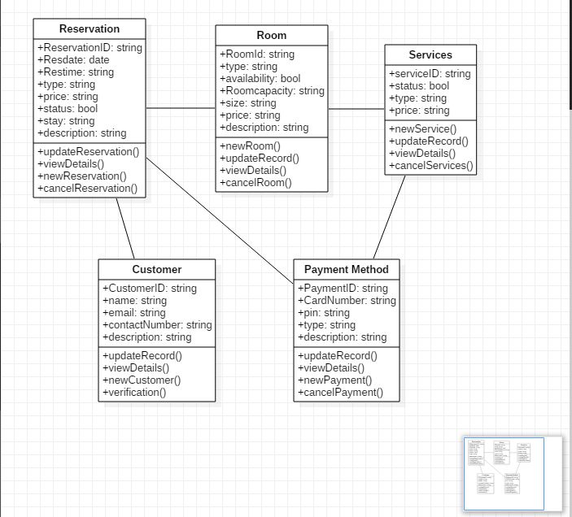

**Task 01: Create a UML Class diagram of the below scenario also include all possible relations.**

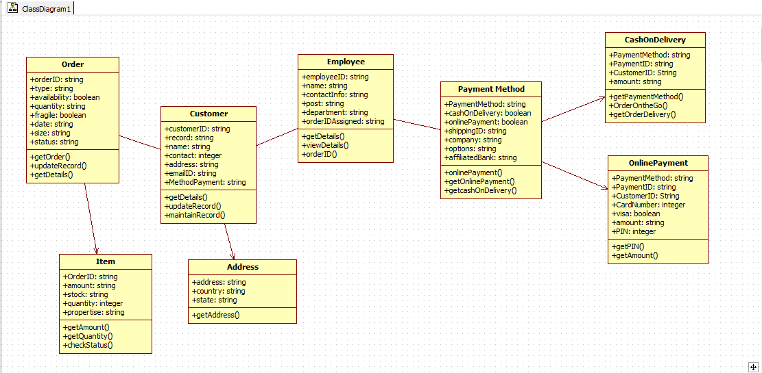

**Task 02: Project Management System:**

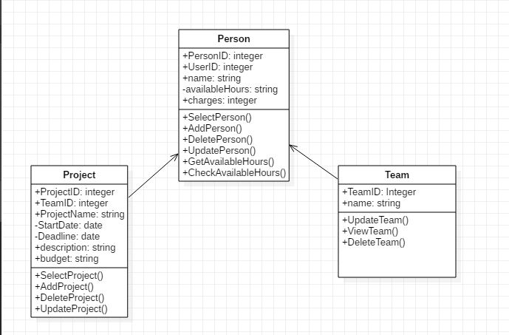

**Task 03: Class Management System:**

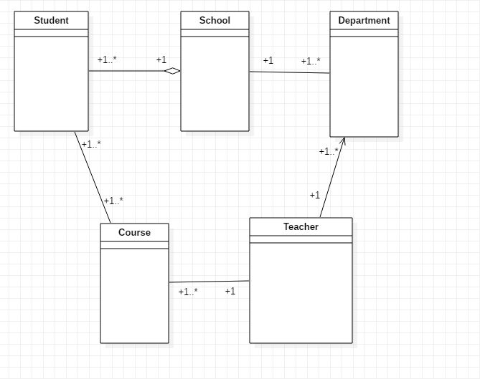

**Task 4 Explain the operations and implement them in starUML**

